Report
Of
Data Science Master Virtual Internship
Submitted
To
School of Computer Science and Engineering
IILM University, Greater Noida, U.P.

In partial fulfilment of the requirement of degree of
B.Tech CSE



By
Roll Number of Student: 2410030661
Name of Student: UJJWAL KUMAR
Batch: 2024-2028
CANDIDATE'S DECLARATION
I, Ujjwal Kumar, do hereby declare that the internship report titled “Data Science Master Virtual Internship” has been completed by me to fulfil the requirement for the award of the degree of Bachelor of Technology in Computer Science and Engineering. All the references used have been duly quoted, and I have not taken as such any material from any other source without acknowledgement. I affirm that this report is my own original work and has not been submitted to any other institute for any degree/diploma requirement, and I shall be solely responsible for any kind of copyright violation in this regard.
Signature
Student Name: Ujjwal Kumar
Roll No.: 2410030661

ACKNOWLEDGEMENT
I am using this opportunity to express my gratitude to everyone who supported me throughout the Data Science Master Virtual Internship Program. I am thankful for their aspiring guidance, invaluably constructive criticism, and friendly advice during this work. I am sincerely grateful to them for sharing their truthful and illuminating views on a number of issues related to this work.
I would like to thank the All India Council for Technical Education (AICTE), the Ministry of Education, EduSkills Foundation, and Siemens Industry Software (India) Pvt. Ltd., for organising this virtual internship under the National Internship Portal and for providing me with an opportunity to gain practical exposure to the field of Data Science.
I would also like to thank the School of Computer Science and Engineering, IILM University, Greater Noida, for their continuous encouragement and support throughout the internship period.
I express my gratitude to my parents for their blessings.
Signature
Student Name: Ujjwal Kumar
Roll No.: 2410030661

TABLE OF CONTENTS
Chapter No. | Chapter Name | Page Nos.
 | Cover Page | ---
1. | Candidate's Declaration | ii
2. | Acknowledgement | iii
3. | Internship Completion Certificate | ---
4. | Project Description | 1
 | 4.1 Introduction | 1
 | 4.2 Organization Profile | 1
 | 4.3 Problem Statement | 2
 | 4.4 Project Objectives | 2
 | 4.5 Scope of the Project | 3
 | 4.6 Technologies and Tools Used | 3
 | 4.7 System Architecture | 4
 | 4.8 Methodology | 5
 | 4.9 Expected Outcomes | 6
 | 4.10 Certificate of Completion | 7
5. | Bibliography / References | 8

Note: Page numbers above are indicative and are auto-generated within this document; Chapters 1-3 use Roman numbering while Chapter 4 onward uses Arabic numbering, as specified in the report guidelines.
3. INTERNSHIP COMPLETION CERTIFICATE
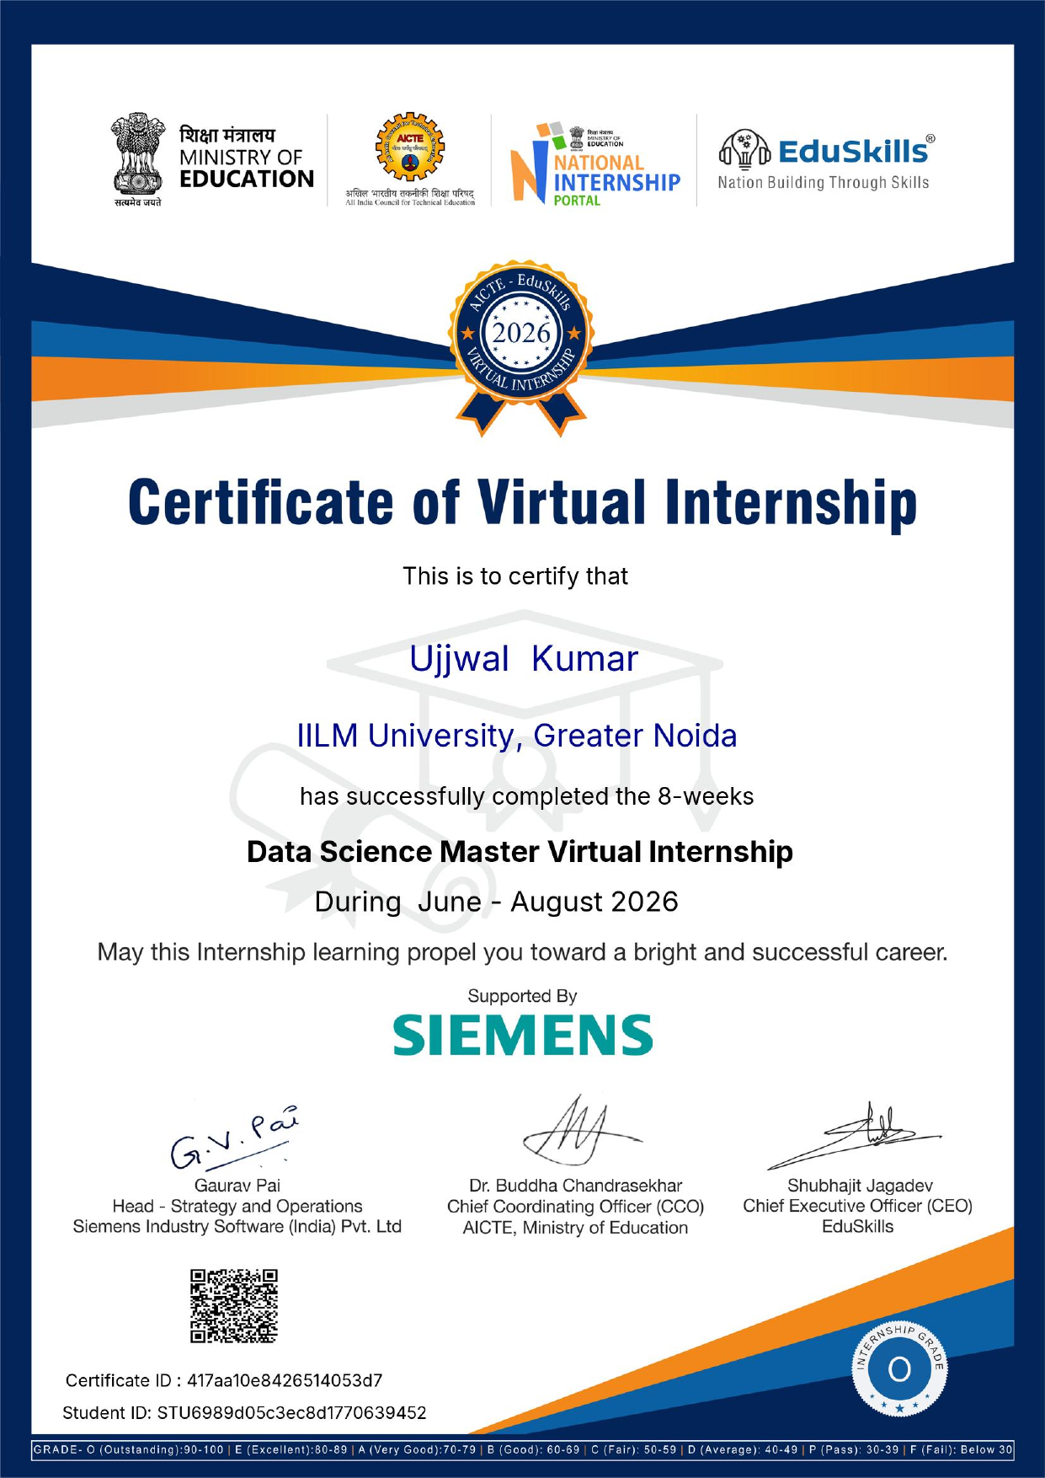
4. PROJECT DESCRIPTION
4.1 Introduction
The rapid growth of digital technologies has resulted in an unprecedented volume of data being generated across every sector of industry, government, and academia. Extracting meaningful, actionable insight from this data has become a critical requirement for organisations seeking to remain competitive, and Data Science has emerged as the discipline that combines statistics, computer science, and domain knowledge to meet this need. In order to bridge the gap between classroom learning and industry practice, the All India Council for Technical Education (AICTE), Ministry of Education, in association with EduSkills Foundation and Siemens Industry Software (India) Pvt. Ltd., offers the Data Science Master Virtual Internship through the National Internship Portal (NIP).
This 8-week virtual internship, undertaken during June to August 2026, was designed to provide students with structured, hands-on exposure to the complete data science workflow, ranging from data collection and cleaning to exploratory analysis, statistical reasoning, machine learning, and the communication of insights through visualisation. This report documents the learning undertaken, the tools and technologies used, the methodology followed, and the outcomes achieved during the course of this internship.
4.2 Organization Profile
Siemens is a global technology company focused on industry, infrastructure, mobility, and healthcare, with a strong emphasis on digitalisation and automation. Siemens Industry Software (India) Pvt. Ltd., the entity supporting this internship, develops software solutions under the Siemens Xcelerator portfolio that enable organisations to design, simulate, and optimise products and processes using data-driven techniques.
The All India Council for Technical Education (AICTE) is a statutory body under the Ministry of Education, Government of India, responsible for the planning and coordinated development of technical education in the country. EduSkills Foundation, operating under the motto “Nation Building Through Skills,” partners with AICTE and leading technology companies to deliver industry-aligned virtual internships to students through the National Internship Portal, with the objective of enhancing the employability and practical skill set of engineering graduates across India.
4.3 Problem Statement
Despite the growing demand for data-driven decision-making across industries, there continues to be a significant gap between the theoretical knowledge imparted in academic curricula and the practical, tool-based skills expected by employers in the field of data science. Many students graduate with an understanding of statistical concepts and programming fundamentals but lack exposure to real-world datasets, industry-standard tools, and end-to-end project workflows. This internship was undertaken to address this gap by providing a structured, mentor-guided, hands-on learning experience that simulates the working environment of a data science professional.
4.4 Project Objectives
- To understand the complete data science life cycle, from problem formulation to model deployment.
- To gain proficiency in Python programming and its data science libraries.
- To learn techniques of data cleaning, wrangling, and exploratory data analysis (EDA).
- To understand fundamental statistical and probability concepts used in data analysis.
- To build, train, and evaluate machine learning models for classification and regression problems.
- To develop the ability to visualise data and communicate insights effectively to a non-technical audience.
- To apply the above skills in a capstone project based on a real-world dataset.
4.5 Scope of the Project
The scope of this internship was limited to a self-paced, virtual learning format comprising recorded lectures, reading material, hands-on assignments, quizzes, and a capstone project, delivered over a period of eight weeks. The internship covered the foundational and intermediate aspects of data science, including Python programming, statistics, data visualisation, and machine learning, but did not extend to advanced topics such as deep learning, natural language processing, or big data engineering, which lie outside the scope of the Data Science Master track. The project work undertaken during the internship was exploratory and academic in nature, intended for learning purposes rather than production deployment.
4.6 Technologies and Tools Used
The following technologies and tools were used during the course of the internship:
- Programming Language: Python 3
- Development Environment: Jupyter Notebook / Google Colab
- Data Handling Libraries: NumPy, Pandas
- Data Visualisation Libraries: Matplotlib, Seaborn
- Machine Learning Library: Scikit-learn
- Database Query Language: SQL
- Version Control: Git and GitHub
- Spreadsheet and Reporting Tool: Microsoft Excel
4.7 System Architecture
The data science workflow followed during the internship can be represented as a sequential pipeline in which raw data is progressively transformed into actionable insight. The architecture of this pipeline is summarised in the table below.
Stage | Description
1. Data Collection | Gathering raw data from files (CSV/Excel) or databases.
2. Data Cleaning | Handling missing values, duplicates, and inconsistent formatting using Pandas.
3. Exploratory Data Analysis | Summarising data characteristics and detecting patterns using descriptive statistics and visualisation.
4. Feature Engineering | Selecting, transforming, and encoding variables for use in models.
5. Model Building | Training machine learning algorithms such as linear regression, logistic regression, decision trees, and k-nearest neighbours.
6. Model Evaluation | Assessing model performance using metrics such as accuracy, precision, recall, and RMSE.
7. Insight Communication | Presenting findings through charts, dashboards, and summary reports.

4.8 Methodology
The internship was structured on a week-by-week basis, progressively building skills from foundational programming to applied machine learning, as summarised below:
- Week 1-2: Python programming fundamentals, and introduction to descriptive and inferential statistics.
- Week 3-4: Data wrangling and cleaning with Pandas, and exploratory data analysis using Matplotlib and Seaborn.
- Week 5-6: Introduction to machine learning, including supervised learning algorithms for regression and classification, using Scikit-learn.
- Week 7: Model evaluation techniques, hyperparameter tuning, and application of learned concepts to a capstone project based on a real-world dataset.
- Week 8: Finalisation of the capstone project, preparation of the project report, and assessment leading to the award of the internship certificate.
Each module was accompanied by video lectures, reading assignments, and hands-on coding exercises, followed by quizzes to reinforce and assess understanding of the concepts covered.
4.9 Expected Outcomes
On successful completion of the internship, the following outcomes were achieved:
- A working understanding of the end-to-end data science life cycle.
- Practical proficiency in Python and its core data science libraries.
- The ability to perform data cleaning, exploratory data analysis, and statistical interpretation independently.
- The ability to build and evaluate basic machine learning models.
- A capstone project that can be included in a professional portfolio.
- An industry-recognised certificate of completion, supported by Siemens and issued through the AICTE-EduSkills National Internship Portal, with a final grade of O (Outstanding).
4.10 Certificate of Completion
A copy of the Certificate of Virtual Internship, issued jointly by AICTE, EduSkills, and Siemens Industry Software (India) Pvt. Ltd., confirming successful completion of the 8-week Data Science Master Virtual Internship with a grade of O (Outstanding), is attached below.


5. BIBLIOGRAPHY / REFERENCES
1. AICTE EduSkills National Internship Portal, Data Science Master Virtual Internship Program, June-August 2026.
2. Siemens Industry Software (India) Pvt. Ltd., Siemens Xcelerator - Learning Resources.
3. McKinney, W., Python for Data Analysis, O'Reilly Media.
4. Geron, A., Hands-On Machine Learning with Scikit-Learn, Keras, and TensorFlow, O'Reilly Media.
5. Pandas Documentation, https://pandas.pydata.org/docs/
6. Scikit-learn Documentation, https://scikit-learn.org/stable/documentation.html
7. Matplotlib Documentation, https://matplotlib.org/stable/index.html
8. All India Council for Technical Education (AICTE), Ministry of Education, Government of India, https://www.aicte-india.org/

